Here is my bio:

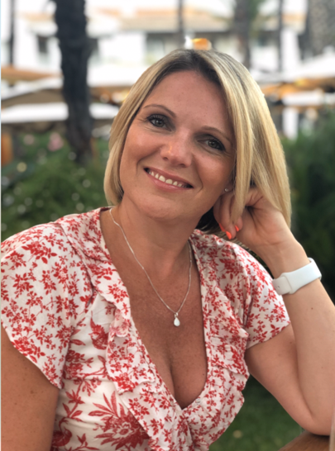Amy Gallagher is a transformational coach and healer, helping senior executives transform the way they lead and live from the inside out. She prides herself on navigating her clients from a place of struggle to one of ease, inspiration and authenticity.

Amy spent 20 years as a senior leader and consultant in the digital industry working for big-brand names such as Amazon, Ebay, Virgin Media, Play.com, Sainsbury’s Argos and many more high-street retailers. Her leadership roles often involved restructuring digital departments as well as coaching and mentoring demotivated and disillusioned teams. Her high energy combined with her compassionate nature meant she always got results and was instrumental in creating high-performing, motivated teams.

During her corporate career, Amy had a bone-deep knowing that her purpose was to help and heal others so she began to train in various coaching and healing disciplines. She has since trained under some of the country’s leading coaches and spiritual mentors. She owns and runs a successful coaching business offering 1:1 and group coaching programmes alongside bespoke packages for senior leadership teams. Her biggest passion is running residential retreats where she can forge an intimate relationship with her clients over a short space of time and witness huge transformational shifts.

**The Resilient Mindset – How to Lead and Live During Turbulent Times**

This webinar will look at:

* how you can respond in a crisis, such as a pandemic, and the emotional/mental challenges you might face
* emotional resilience
  + what is it?
  + how can you build more emotional resilience yourself and in the people around you?
  + how does emotional resilience support you during turbulent times?
* practical tips on how to build a resilient mindset for you, your teams and your organisation

**Poll Questions:**

Which of these are you experiencing more of during the pandemic?

* Anxiety
* Anger
* Frustration
* Sadness
* Hopelessness
* Depression
* None of the above

What state of consciousness have you been operating in over the past 6 months?

* Life happens to me
* Life happens by me
* Life happens through me
* Life happens as me
* I can move up and down the states frequently in any given day

Is this different to how you would normally operate outside of a pandemic?

* Yes
* No
* Not really

Let me know if you need anything else. I’ll get the final presentation over to you before the 4th.

Warm wishes

Amy